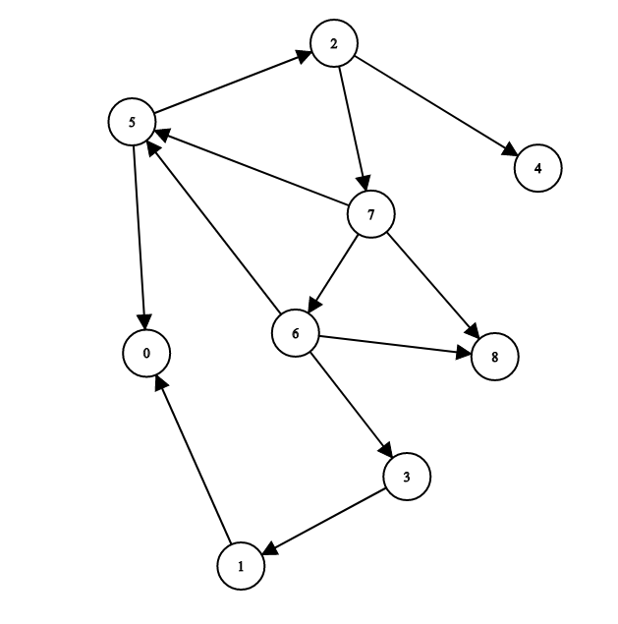 | Adjancecy LiTS  0 : null  1 :0  2 :4 7  3: 1  4: null  5 :0 2  6: 3 5 8  7: 5 6 8  8 : null  STACK 5  print 5 2 7 8 3 1 6 4 0  stack 0 2  stack 0 4 7  stck 0 4 6 8  stcak 0 4 6 3  stack 0 4 6 1  stack 0 4 6  stack 0 4  stack 0

